a.1.1b Optical system for THz detectors linear arrays.
To obtain the image using THz detectors linear arrays, it is important to create an optical system, which allows the focusing of THz radiation into each detector simultaneously. This configuration of optical system reduces the scanning time. For this aim we modelled and manufactured such system which consists of two parts. The first part includes the pair of lenses that focus the radiation on the object, the second ones - on THz detectors. We used for the first pair of lenses spherical and cylindrical ones for obtaining THz radiation distribution in the line. Efficiency of this type of lenses was tested on set-up presented in Fig. 5. The scheme consists of a sub-THz source, lenses, MCT sub-THz detectors, registration system and computer with software.
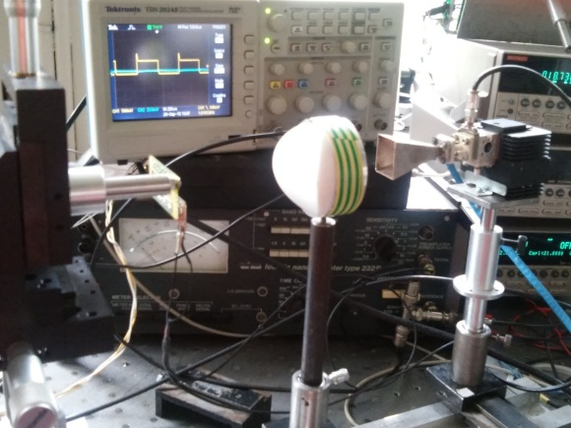
Fig. 5. Photo of set-up for pair of spherical and cylindrical lenses testing.

The sub-THz source was used as the emitter that generates a continuous, linearly polarized, essentially monochromatic wave at 140 GHz. This scheme was chosen as an intermediate for scanning simulating the illumination in the plane of installation of object.
Manufactured cylindrical lens and spot diagram, created by passing a sub-THz beam through the pair of spherical and cylindrical lenses are presented in Fig. 8-9, respectively. A lens spot diagram is the best overall evaluation for a quick check of image quality. Aspects such as astigmatism, coma, spherical aberration, chromatic aberration and more can be viewed instantly.

Cylindrical lenses are more difficult to manufacture than spherical lenses. After the manufacturing it is necessary to ensure that the lens focuses the radiation to a single axis and works correctly. The lenses were milled on a computer-controlled lathe, resulting in a surface roughness of less than 30 μm (∼λ /10). It has been suggested to manufacture lenses using 3D printing (MakerbotReplicator 2X). The result is shown in figure 10-12. The lenses made with using 3D print have better capability of reproducing of the Gaussian curve, but they need an additional surface treatment to increase the level of radiation signal.
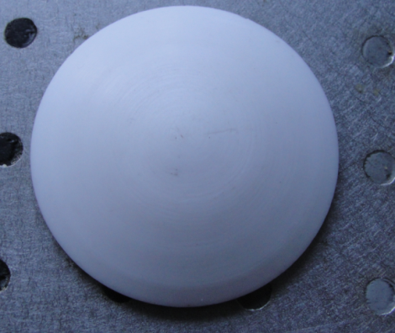 | 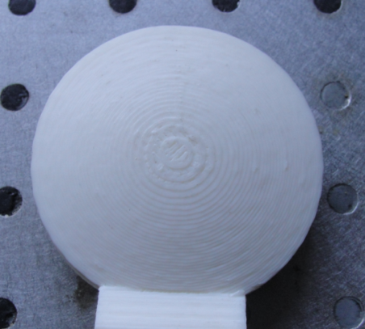
Fig.10. Photo of the lens, made on a computer-controlled lathe. Lens material was PTFE. | Fig.11. Photo of the lens, made with using 3D print. Lens material was ABS.
Fig.12. The comparison of the spot diagrams of lenses made on a computer-controlled lathe (a) and with using 3D print (b).

For all of the lenses presented here, we have chosen a focal length of 25 mm and a diameter of 60 mm, therefore the numerical aperture was 1.2 for all lenses (NA = d/(2 f)). These lenses have unique profile which eliminates monochromatic aberrations. All of the lenses were tested on the manufactured set-up and showed satisfactory quality for THz imaging system. 3D print of the THz lenses has perspective for their using in THz vision systems.

